**Question 1**

* 1. Circuit Diagram

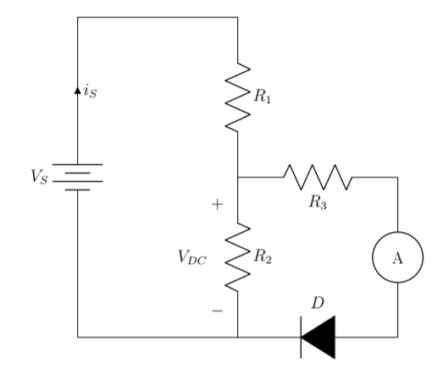

Either the ammeter or voltmeter diagrams work, don’t need both, just one

* 1. Fraction of Vs across R3 and the Diode

R2/(R1+R2) = 100/780

* 1. Knee Voltage

Anywhere between 0.4 and 0.6

* 1. Plot of VDC vs I
  2. Plot of VDC vs VPN

**Question 1**

Dene all parameters and variables in Equation (2).

|  |
| --- |
|  |
| ID = Current through the diode |
| VPN = Voltage drop across the diode |
| IS = Saturation/Reverse current, diode current due to diffusion |
| q = magnitude of the elementary charge (1.602 * 10-19 C) |
| ν = ideality factor |
| kB = Boltzmann constant, 8.617 * 10-5 eV/K |
| T = Temperature in Kelvin |

**Question 2**

**Question 3**

Is = intercept with the y axis. On the 10-9 range.

anything from 1.5-2.5 or so should be fine

Rs = 1.40 Ohms (what I got, anything is fine as long as it is justified correctly)

**Question 4**

**Question 5**

Theoretical:

IS = 25 nA

RS = something low

v = 2.3

As long as they explain whether it’s higher or lower and percent error

**Exploration**

Si Diode

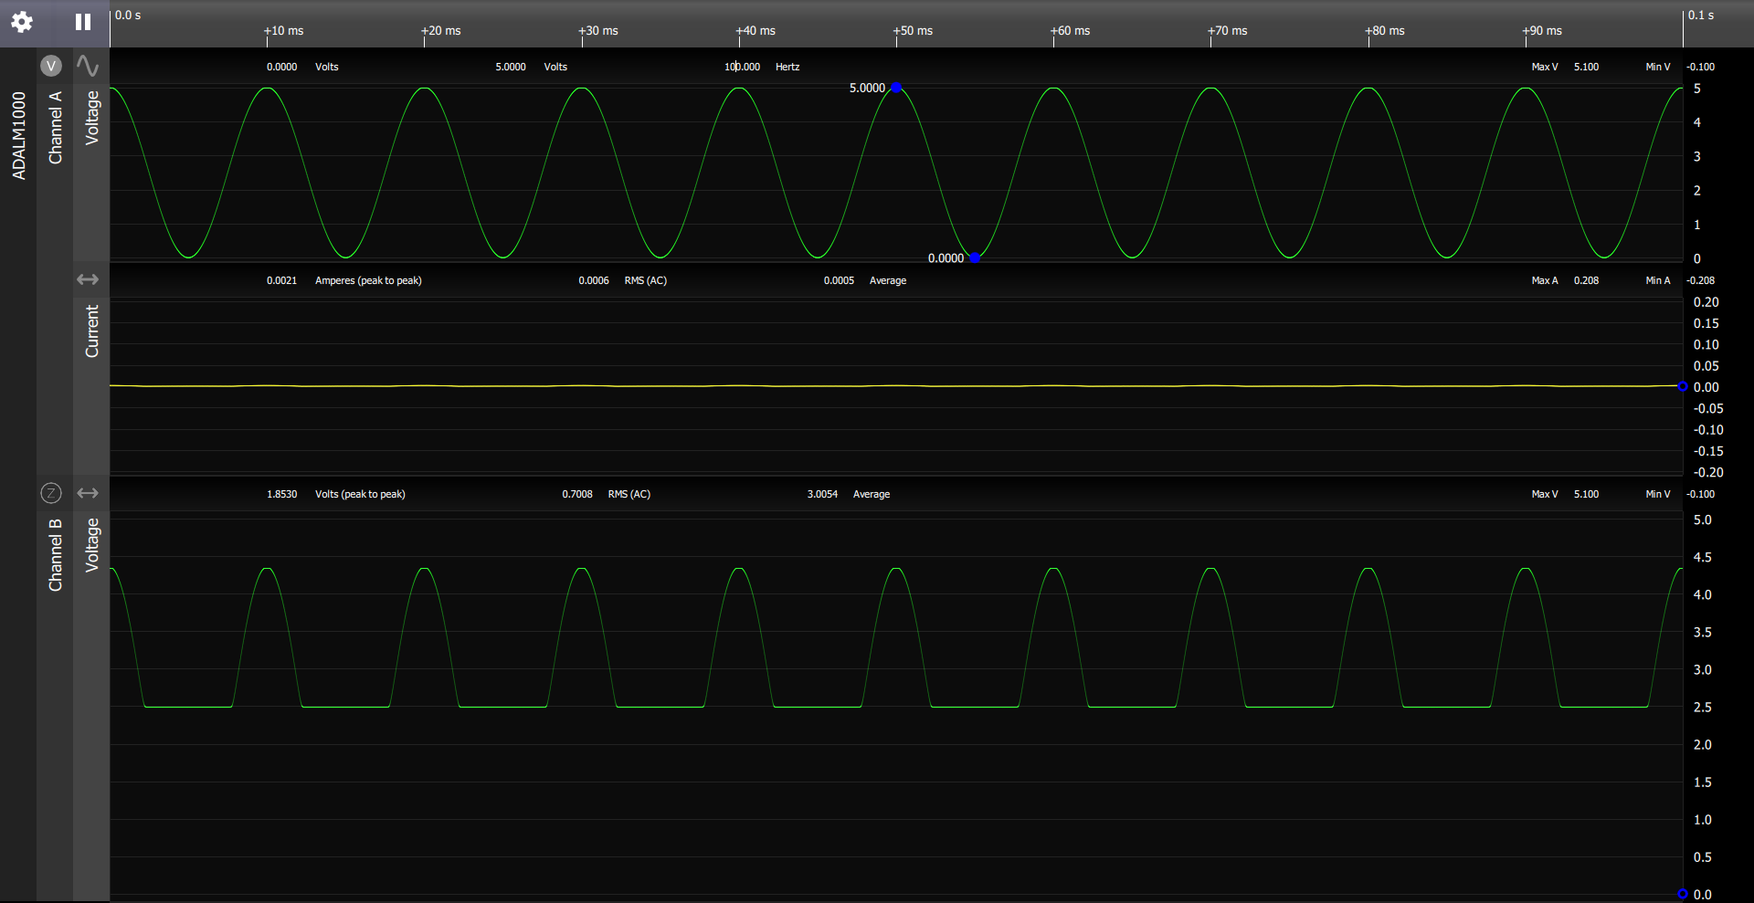

Max Voltage of rectified waveform is smaller by 0.647V. This is caused by the diode because it takes roughly 0.647V for the diode to turn on.

Si Diode with capacitor

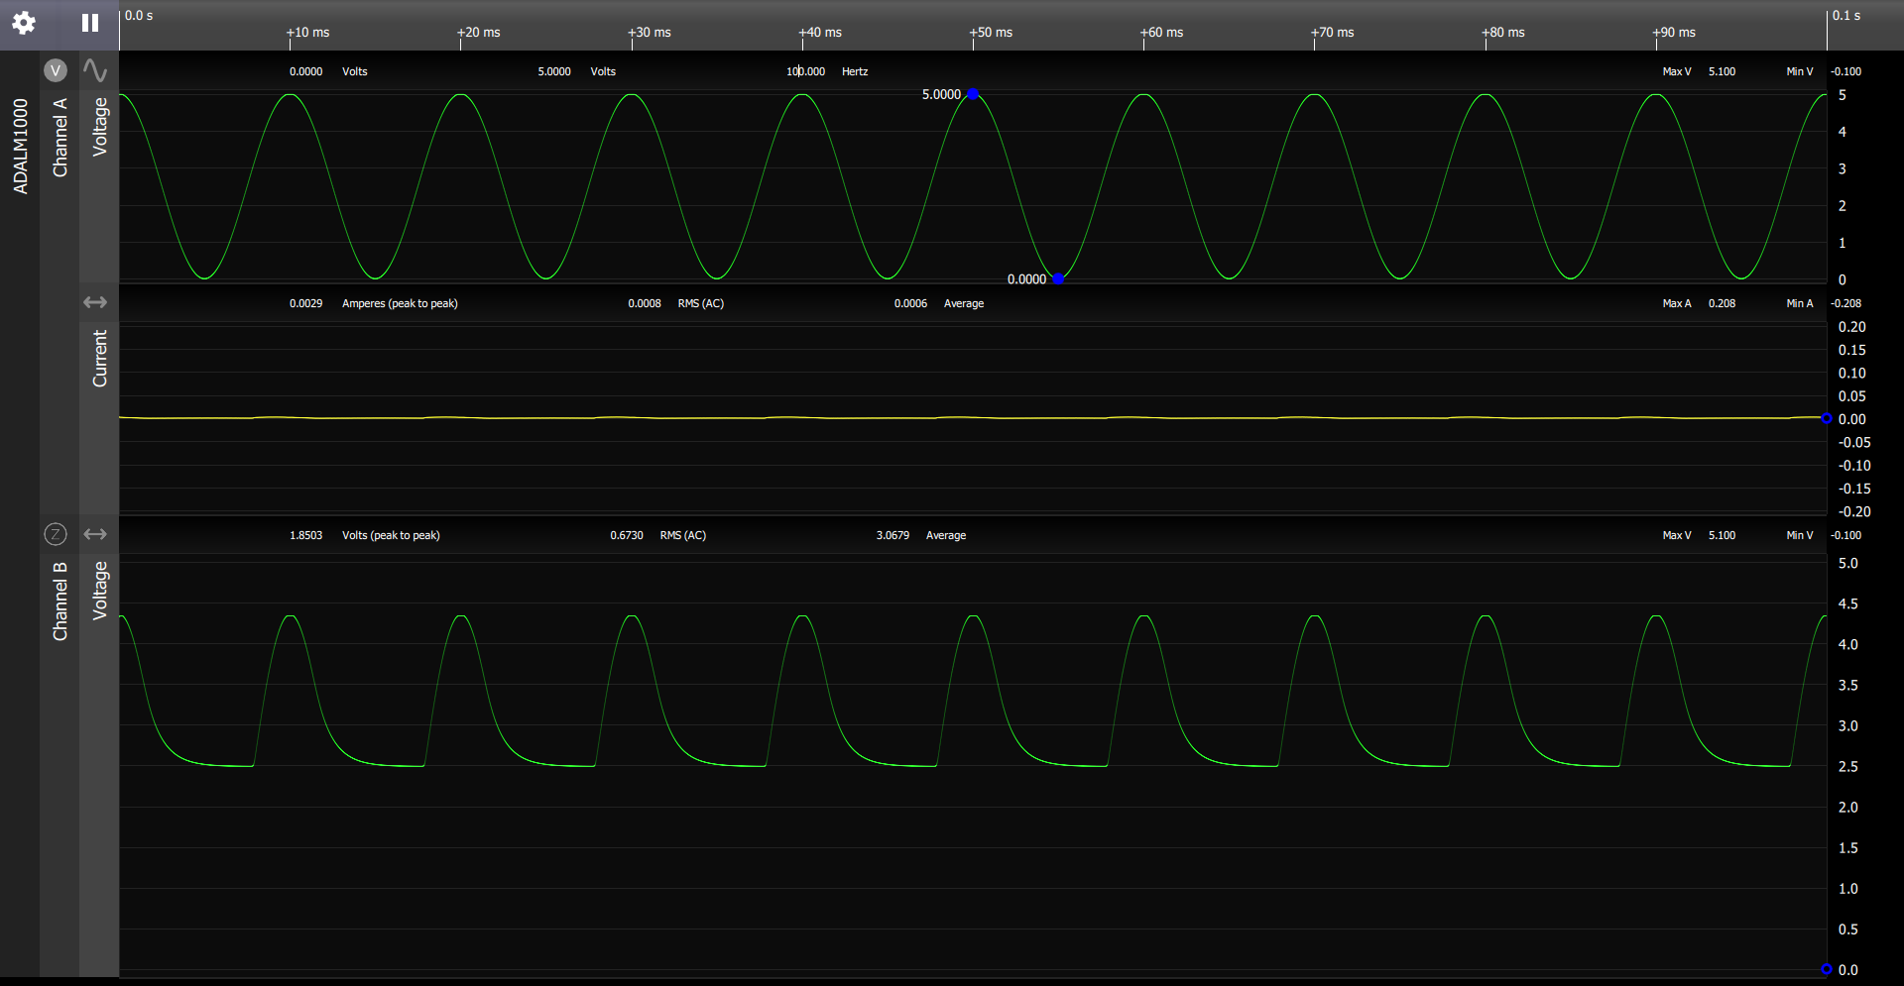

Less sinusoidal, smooth decrease, useful for when want current to flow only in one direction or bursts of voltage.

GE Diode

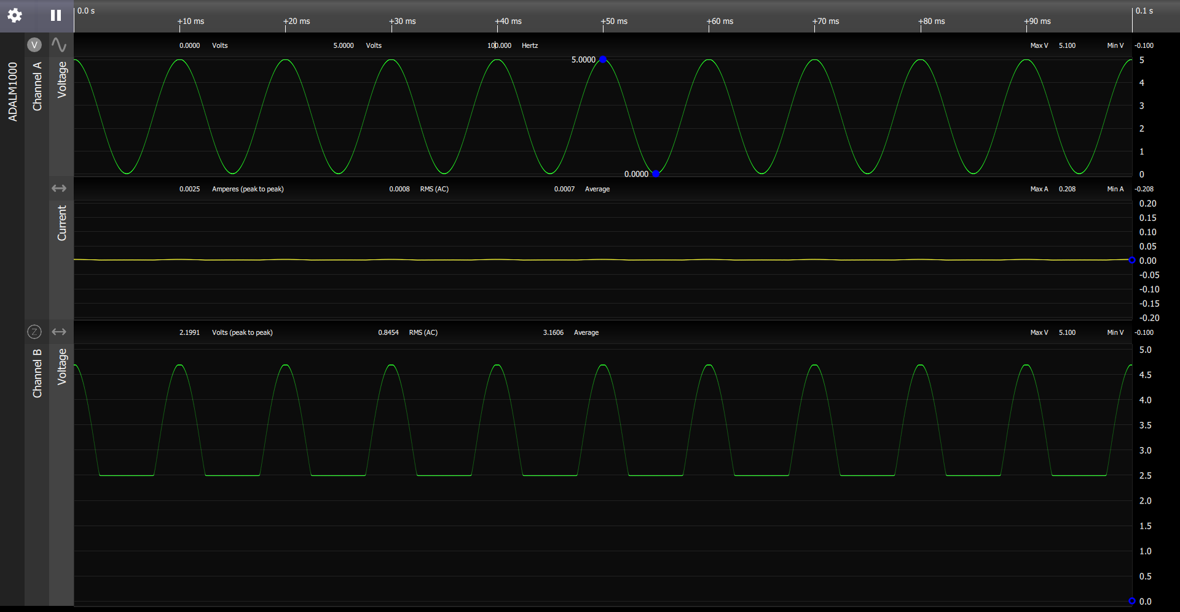

GE Diode with capacitor

